‘’

[Date]

Team LOCALHOST

Agile systems

AR-VR PAAS

[Document subtitle]

**Project Title: AR – VR PaaS**

**Group Name: LOCALHOST**

**Group Members:**

|  |  |  |
| --- | --- | --- |
| **NAME** | **SAP ID** | **ROLL NO.** |
| **Aditya Kumar** | **500066319** | **04** |
| **Anuj Verma** | **500066910** | **09** |
| **Dhananjais Kalra** | **500070904** | **14** |
| **Maybank Joshi** | **500070105** | **25** |

Contents

Introduction 3

Objective and Aim 4

Requirements (as for now) 5

# ABSTRACT

AR and VR technologies use high amount of graphics and processing in order to work, which ultimately require high performance machines that are quite expensive. So if a person wants to utilize this technology, they will have to shell out a significant amount of money just on the machine itself which is not very cost effective. As rapid technological changes have become a general scenario today, purchasing such machines which support AR-VR can be categorized into a bad and obsolete investment.

The best example for the above mentioned problem can be taken of a freelance developer. A freelance developer may have a project that requires the use of AR or VR once in a while. Also for one project he may require a comparatively simpler machine and for other he may require a whole set of advanced configurations. Thus, making the job of acquiring and updation expensive as well as tedious. In such scenario, upgrading his machine will constantly require to stress out a lot of money which may lead to financial troubles. Also these machines are not exactly user friendly when it comes to carrying them or in their maneuverability. Therefore the best possible way to counter such limitations is to bring the facility of AR-VR to users with the help of online platforms. They are cheap, easily accessible and can bend to the users will. They can provide the same facilities to all users on any device using cloud services.

Another example can be taken for a university where they will be requiring machines for every student that opts for a course that uses AR or VR technology based learning/creation. To fulfil those needs they will have to constantly upgrade their hardware as per the needs and all the hardware will also be requiring maintenance which leads to high costs.

Our product aims to provide AR-VR Platforms Asa Service where people/organizations will be able to use our cloud platform as per their requirements. Our platform will give them capabilities to render anything and everything on cloud using our servers. All the services provided will use basic configuration machines and generate high quality content which otherwise would not be possible with a low end system.

This platform will be used on commercial basis. Users will be able to get access to our service on pay per day basis or a long term plan. Our platform will also provide the feature/capability of scalability which will allow them to upgrade or downgrade their cloud machine capabilities/performance as per their current needs allowing them to pay only for what they use rather than paying for a high performance machine all at once which may or may not be of their later on.

# 

# Introduction

The field of software development and management has significantly grown in the past ten years. At a point in time, the basic need of common populous was to just sort out their grocery lists but today, software in itself have become a major part of everyone’s day to day life. Innovations and changes in computer software are a very common occurrence in this time. This is all because the users around the globe today, are driven by the zeal of living life virtually than in reality. As such, the concept of **augmented reality** and **virtual reality** has become a booming market today.

This project is based on latest and emerging technologies of **Augmented Reality and Virtual Reality**. The main purpose of AR-VR is to provide consumers with a sense of living a limitless virtual life, which is free of any obligations. Following this idea and principles and values of agile manifestos, we are developing a **Platform as a Service** for the users who want to create their own Augmented Reality and Virtual Reality content. The services provided in this platform will target every user on any device, unbiased towards the hardware requirement. The main idea is to generalize AR-VR creation to all the users that need it, without constructing any hardware limitations.

Even though this technology itself is not complex in nature, the use of AR-VR is confined to a small group of people. This limitation is as such because of the high configuration it demands from the hardware and network. The maneuverability of this technology highly depends upon the hardware and software it is running on.

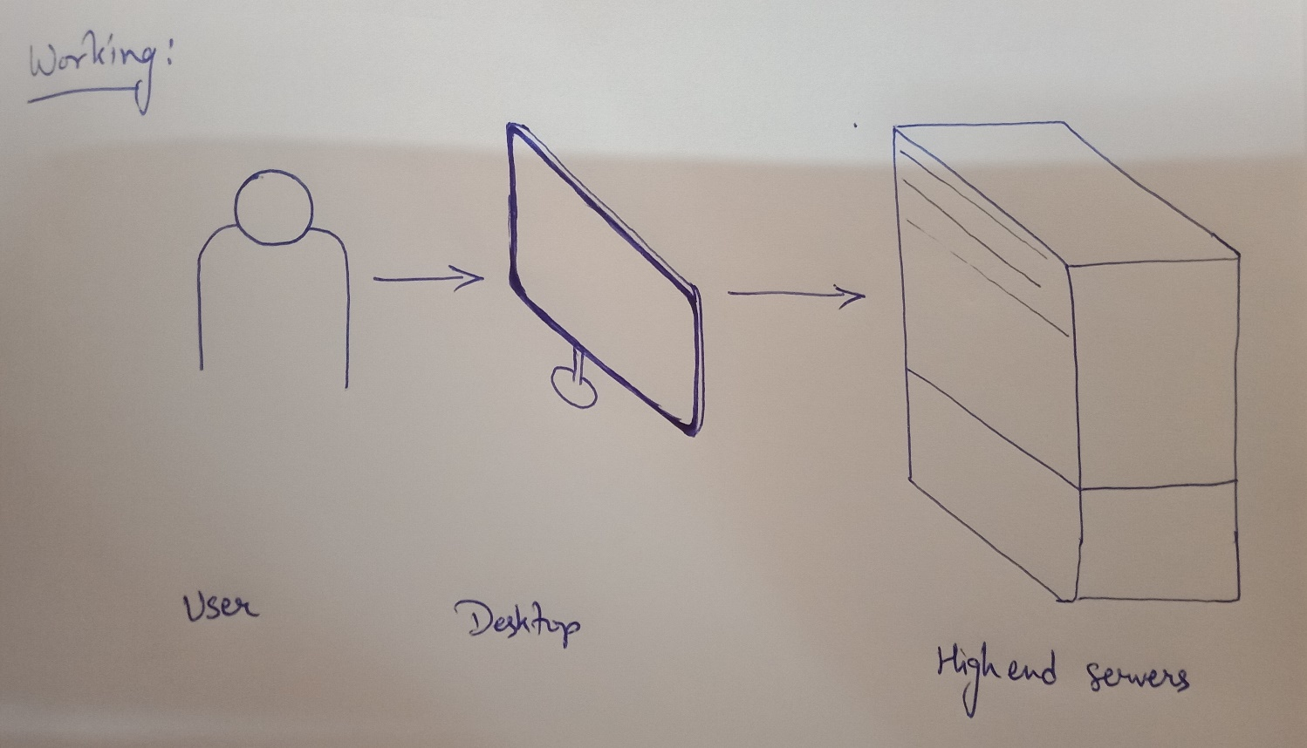

Our platform will eliminate this limitation to the best possible extent and provide users with the same services, unbiased towards the network or hardware they are using. Creation, modification, save and download are the four main services we will provide on this platform. The service will fulfill all the needs of the user in generating AR and VR content. The software will run on our servers and an instance of the process will be displayed on the user’s desktop.

Additional services provided on this platform might also include a marketplace for selling and buying the AR and VR content, creating a community in itself. We aim to create this platform very user friendly, so that users can access, modify and create whatever they want without restrictions. All of the processes, from creation to modification, will be contemplated in real time. The users will also be given services to save and download their content on their systems or on the cloud for further alterations.

Concerning the financial factors, this platform will be made accessible to consumers on a subscription basis only. The platform will be developed exactly according to the needs of the customers.

# Objective and Aim

* This platform can provide development of AR and VR content such as videos, photos and applications
* This platform can also work as a marketplace for users to create and sell their AR and VR content
* Provide the service to people who cannot afford high performance hardware (by giving them subscription service to our platform)
* Provide service to institutions and organizations for mass use at low cost.

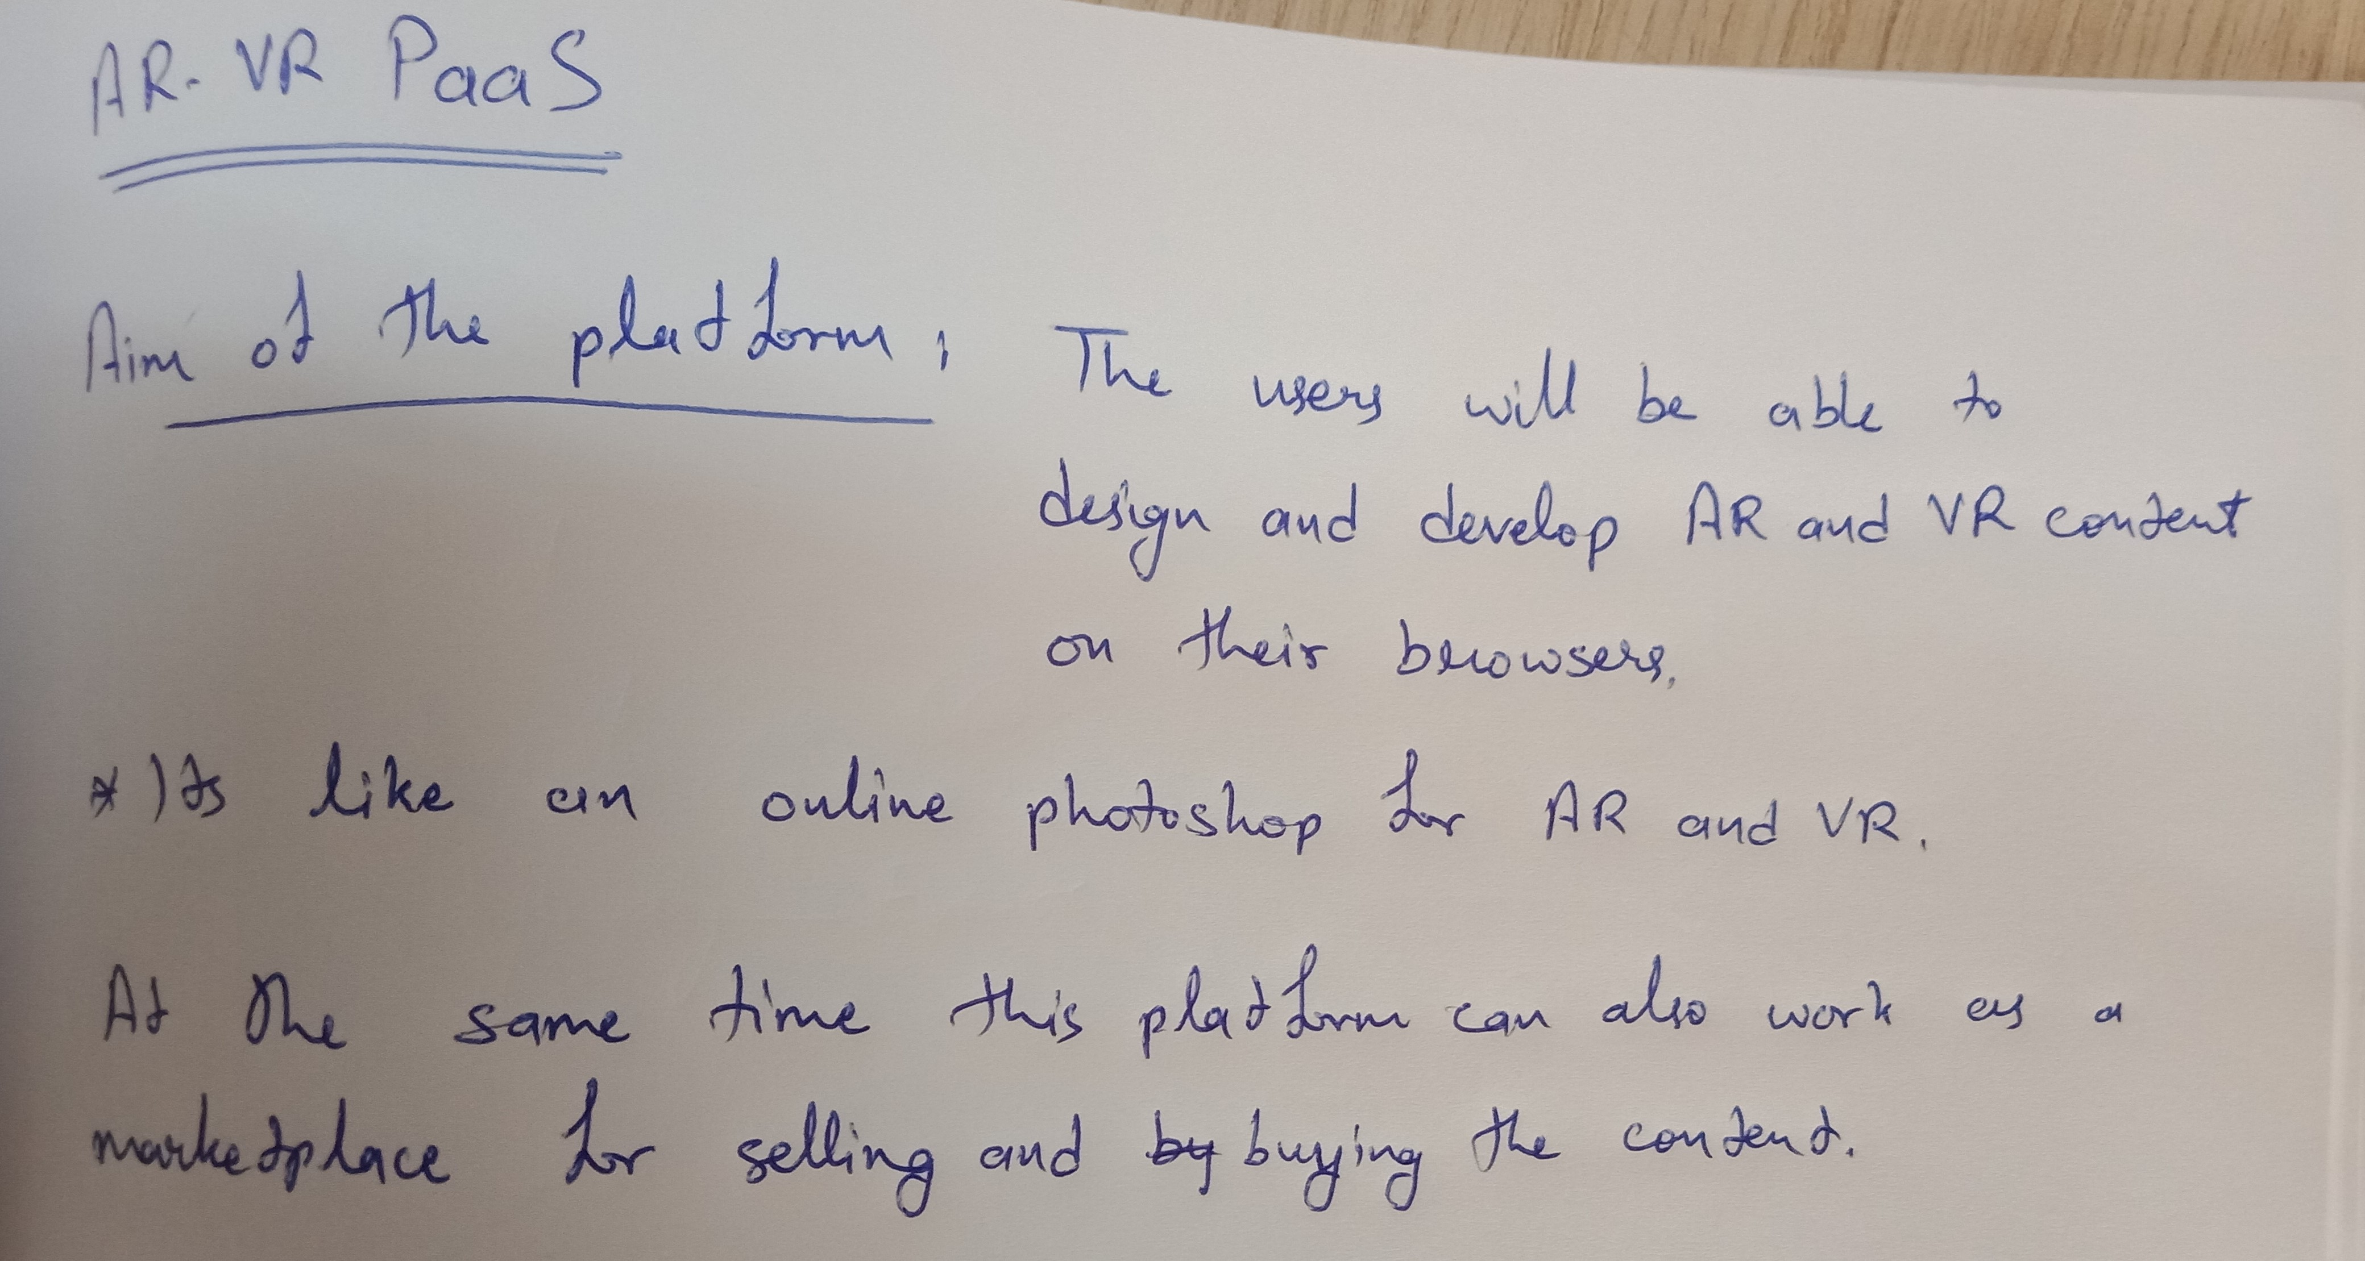

# Requirements (as for now)

* Server Side

1. Cloud Infrastructure (High performance)

2. Internet connectivity (Low latency, high speed fiber optic/5G)

3. Website as a web platform (API also)

* Rapid Application Development methodology of software development

(Server preferences: AWS, Photon Engine)

* User end

1. Computer with basic GPU

2. Internet connectivity (high speed fiber optic/5G with low latency)

3. VR headset (for VR content)

4. Smartphone Application (if used on smartphone)